Delimiter1

Table of Contents

Delimiter Text 1

# Delimiter Text

A Delimiter is a character that separates two strings.

**It Supports Comma (,), Dollar($), and Pipe (|).**

**To work with Delimiter Text**

1. Under the **Reports** area, select the required folder to view the reports under it.

2. Right-click the required report, and then click **Schedule.**

      (or)

   For the required report, click icon, and then click **Schedule**.

3. **Schedule-Report** dialog box appears.

4. In the **Schedule-Report** dialog box, click the **Output & Delivery** tab, in it click **Add Output**.

5. Under **Output and Deliveries** section, in the **Output Type** box, select the required output.

Required Output type: Delimiter Text (,)

6.  In the textbox beside the **Output Type** box, type the required delimiter as shown below:

Required Delimiter: , or $

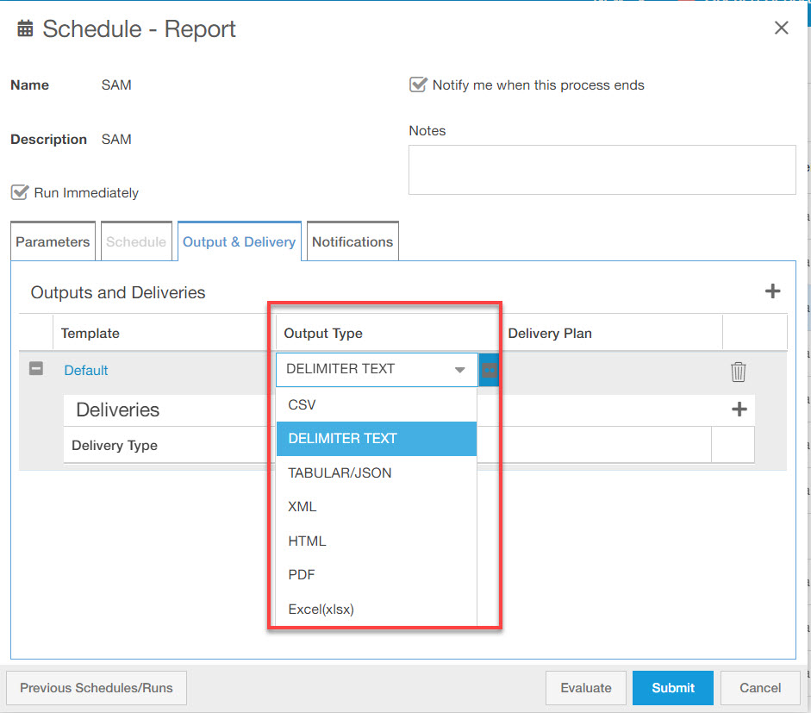

In the **Delimiter Text** drop down click  below figure appears.

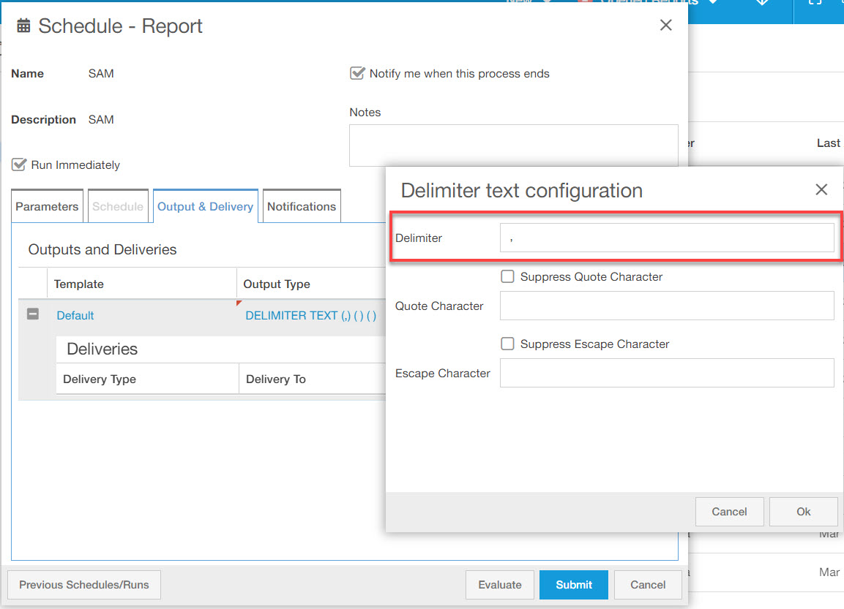

7. **Output Type** appears as shown below:

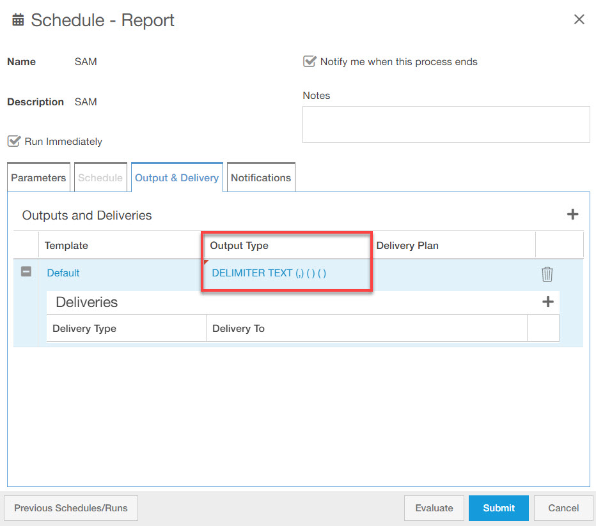

8. To submit the process, click **Submit.**

9. The process gets submitted with a process id.

**Verifying Delimiter Text Option**

1. On the left-hand side, point to **Monitoring**, and then click **Processes.**

2.  **Scheduled Processes** section appears with a list of available processes.

3. Select the required process.

4. To download the output file click **Output** file, under **Output(s) & Delivery** section, .

6. The text file appears with the required delimiter between the values as shown below:

